PHÒNG GD & ĐT HẠ LONG
TRƯỜNG TH BÃI CHÁY
HƯỚNG DẪN ÔN TẬP HỌC KỲ II MÔN TIẾNG ANH 3
NĂM HỌC 2019 – 2020
I. Lí thuyết
1. Cấu trúc ngữ pháp
 | Write the answers | Meaning the answers
1- Who’s that?
2- How old is your father?

3- Is there a pond?
4- Where’s the map?
5- Where are the chairs?
6- Are there any posters in the room?
7- Do you have any toys?

8- Do you have any pets?

9- What toys do you like?

10- What are you doing?
11- What is he/ she doing?
12- What are they doing ?
13- What’s the weather like ?
14- Where’s SaPa ?
2. Từ vựng:
Ôn tập từ vựng từ Unit 10 đến Unit 20
Words | Meaning the words | Words | Meaning the words
Family |  | Poser
Father |  | Bed
mother |  | Chair
Grandmother |  | Picture
grandfather |  | Coat
sister |  | Ball
brother |  | Where
Living room |  | Near
kitchen |  | Under
bathroom |  | On
bedroom |  | In
dining room |  | Behind
garden |  | In front of
truck |  | Next to
pond |  | Map
yard |  | Sofa
here |  | Wardrobe
over there |  | Fan
fence |  | Cupboard
tree |  | Door
gate |  | Mirror
Doll |  | Window
Teddy bear |  | Cup
car |  | How many
robot |  | Cat
ball |  | Goldfish
ship |  | Parrot
Yo-yo |  | Rabbit
plane |  | Read
Have/has |  | Cook
kite |  | Watch TV
dog |  | Sing
puzzle |  | dance
Cycle |  | skate
Park |  | Draw a picture
Sunny |  | Play the piano
Rainy |  | Listen to music
Cloudy |  | Skip
Windy |  | Snowy
stormy |  | Weather
Ha long Bay |  | Central
North |  | City
south |  | Far
II. Bài tập:
PART 1. LISTENING
Question 1:Listen and number. ( P.61- U19 )
A. It’s sunny.
B. It’s rainy.
C. It’s cloudy.
D. It’s snowy.
Question 2: Listen and tick A, B or C( P.7- U11 )
1. a) He’s my grandfather. _____
b) He’s my father. _____
c) He’s my brother. _____
2. a) She’s my mother. _____
b) She’s my grandmother. _____
c) She’s my sister. _____
3. a) That’s my father. _____
b) That’s my brother. _____
c) That’t my grandfather. _____
Question 3: Listen and circle.( P.53- U18 )
What are you doing?
1.I’m ……………… . A. cleaning the floor B. reading
2.I’m ……………… . A. watching TV B. listening to music
3.I’m ……………… . A. drawing B. cooking
Question 4: Listen and write. (P.16- U12 & P.44-U16 )
1. The ………………………………….. is large.
2. Is there a …………………………………….?
3. Peter has a ………………………………….. .
4. Nam has a …………………………………. .
PART 2. READING AND WRITING
Question 5: Read and complete.
like has trucks many ten cats

I have many toys. I have five (1) …………….., three planes, and (2)……………. yo-yos. My friend Mary has some pets. She (3) ……………. two dogs and three (4)…………………. . What about you? What toys do you (5) ………………..? How (6) ………………. pets do you have?
Question 6: Read and complete .
skating playing weather flying park skate

The (1)………………..is fine today. It is sunny and windy. We are in the (2) ………….. . Mai and Linda are (3)…………..…… kites. Nam, Phong and Tony are (4)………………… football. Peter and Quan are (5) ……….………… .We are happy together.
Question 7: Read the text and tick ( ) True or False.
Hi. My name is A Vung. I am eight years old. My family is in SaPa. It is in north of Viet Nam. SaPa is near Lai Chau but very far from Ha Noi. There are a lot of mountains and trees in my place. How about your place? Where is it in Viet Nam?

 | T | F
1.His name is A Vung.
2. His family is in SaPa.
3. SaPa is in south of Viet Nam.
4. SaPa is near Da Nang but very far from Ha Noi.
5. There are a lot of mountains and trees in SaPa.

Question 8: Read the text and tick ( ) True or False.
Hi! My name is Mai. I am eight years old. I have a dog, two goldfish and three parrots. This is my dog. It is at the door. These are my goldfish.They are in the fish tank. And those are my parrots. They are in the cage. I love my pets very much.

 | T | F
1. Her name is Mai.
2. Mai has a dog, two cats and three parrots.
3. The dog is under the table.
4. The goldfish are in the fish tank.
5. Her parrots are in the cage.

Question 9: Reorder the words. There is ONE example for you.
Example : that/ Who / is ? Who is that ?
1. house / There / my / is / a / in / living room/ .....................................................................
2. fence / there / a / Is /a / yard/ and/? .............................................................................
3. a / have / and / a / Do / doll/ you/ ball?..............................................................................
4. my/ She/ grandmother/ is / ……………............................................................................
5. many/ do/ How/ kites/ have/ you/?....................................................................................
6. the / is/ Where/ poster/ ?....................................................................................................
7. room / the / in / posters / any / there / Are/ ?.....................................................................
8. an/have/ Do/ planes/ you/?................................................................................................
9. I/ music/ am/ to/ listening/ ...............................................................................................
10. sister/ My/ is/ homework/ her/ doing/ ?...........................................................................
11. doing/ are/ What/ you/ ?...................................................................................................
12. today/ the/ is/ What/ weather/ like/?................................................................................
13. sunny/ is/ Ho Chi Minh City/ It/ in/ …………................................................................
14. Hai Duong/ Where/ is/ ?..................................................................................................
15. Can Tho/ is/ in/ Vietnam/ south/ ………….....................................................................
16. playing/ park/ I/ football/ the/ am/ in/ …….....................................................................
Question 10: Look and write. There is one example.-Example:siwm → swim

1. caneling eht ooflr = ………………….. | 2. ippskgni= …………………  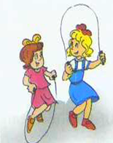 | 3. ospetr = ……………..  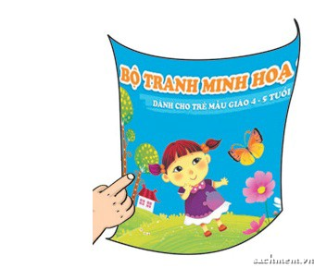
4. rtibba = ………………… | 5. zzpuel = …………….. | 6. airyn= ………………
7. ouclyd = …………… | 8. wenytt = ………………. | 9. argend =………………  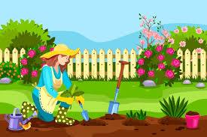
Question 11: Answer the questions about you.
1. Do you have a doll?...........................................................................................................
2. What pets do you have ?....................................................................................................
3. Is there a yard in your house?….......................................................................................
4. What toys do you like?………………………….............................................................
5. What the weather like today?……………………………………………………………
6. Is your place near Ho Chi Minh City?…………………………………………………
7. How old is your father?…………………………………………………………………
8. Do you have any dogs?…………………………………………………………………
Question 12: Matching the each question to each answer
1. Are there any posters on the wall? | a. He’s reading. | 1-
2. Is Ha Long Bay near Hue? | b. She is sixty years old. | 2-
3. Do you have a robot? | c. Yes, she does. | 3-
4. How many chairs are there in the bedroom? | d. There are three chairs. | 4-
5. How old is your grandmother? | e. No,it isn’t. It’s far from Hue. | 5-
6. Is your house big? | f. Yes, there are two. | 6-
7. What’s the weather like? | g. No, it isn’t. It’s small. | 7-
8. Are the books on the table? | h. Yes, I do. | 8-
9. What is he doing? | i. It’s sunny. | 9-
10. Does your sister have a kite? | j. Yes, they are. | 10-

PHÒNG GD & ĐT HẠ LONG
TRƯỜNG TH BÃI CHÁY
HƯỚNG DẪN ÔN TẬP HỌC KỲ II TIẾNG ANH 4
NĂM HỌC 2019 – 2020
I. Lí thuyết
1. Cấu trúc ngữ pháp
 | Write the answers | Meaning
1. What time is it?
2. What time do you get up?

3. What does your father do?
4. Where does he work?
5.What’s your favourite food?

What’s your favourite drink?

6. Would you like some bread?

7. What does your mother look like?

8. Who’s taller?

9. When is (Teacher’s day/ Christmas/
New Year/
Children’s Day? )

10. What do you do at Tet?

11. Let’s go to the…….

12. Why do you want to go to the supermarket?
13. How much is the blouse?

14. How much are these sandals/ jeans/ trousers/shoes?
15. What’s your phone number?
16. Would you like to go for a walk/ go fishing?

17. What animal do you want to see?
18. I like monkeys because………
I don’t like tigers because………
19. Where are you going this summer?

20. What are you going to do this summer?

2. Từ vựng:
Ôn tập từ vựng từ Unit 11 đến Unit 20
II. Bài tập
Question 1: Listen and number.
- My father is a doctor. C. My brother is a driver
- My grandfather is a farmer. D. My mother is a teacher
Question 2: Listen and write the prices.
1. How much are these sandals? They are....................................
2. How much are that pair of jeans? They are....................................
3. How much are these shoes? They are....................................
4. How much are these trousers? They are....................................

Question 3: Listen and circle
What do they do at Tet?
1. Phong…………………………………….
a. buys flowers b. decorates the house.
2. His parents …………………………………….
a. go shopping b. make banh chung
3. His sister…………………………………….
a. wears new clothes b. gets lucky money
4. Phong and his sister…………………..
a. watch firework displays b. gets lucky money.
Question 4: Listen and tick.
1. What’s Tom’s phone number?
a. 0999 291 295b. 0999 291 296 c. 0999 291 297
2. What’s Mai’s phone number?
a. 0998 093 586 b. 0998 093 576 c. 0998 093 596
3. What’s Mr Loc’s phone number?
a. 0990 283 855 b. 0990 283 866 c. 0990 298 877

Question 5: Choose a correct word from the box and write it next to numbers.

the is money party because display

It is (0) …the……. New Year’s Eve. It is nearly midnight. Nam and his father are watching the fireworks (1)……………………..by HoanKiemLake. It is colourful and beautiful. He is very happy (2)………………..the New Year is coming. He is going to have a big (3)…….. at home. He is going to get (4)…………… from his parents. They are going to have a good time.
Question 6: Read the text and tick ( ) True or False.
At weekends, Mai often goes for a picnic with her family in the countryside. She wants to relax and enjoy the scenery. She likes playing badminton and sing English songs, and she enjoys taking photographs with her mobile phone. She also likes cooking dinner for her family.

 | T | F
1.Mai often has picnics with her friends at the weekend.
2. She wants to relax and enjoy the scenery in the countryside.
3. She likes playing badminton and sing English songs.
4. She likes taking photographs with her mobile phone.
5. She doesn’t love cooking for her mother and father.

Question 7: Look and write. There is one example.
Example:siwm → s w i m

1. ourstres = ……………..  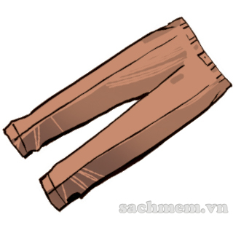 | 2. edabr = …………………
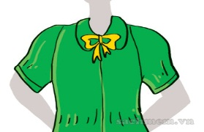  3. seloub = ……………. | 4. .harpaycm= ……………..
5.gaosronak= ……………….  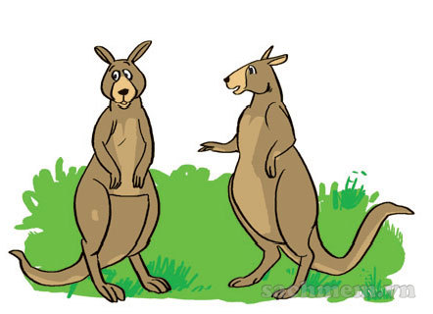 | 6. oocrledics. =………………  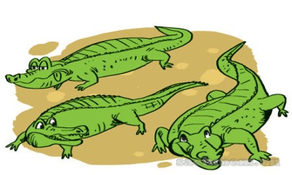
7.frasc  = ……………..  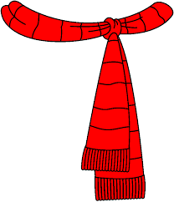 | 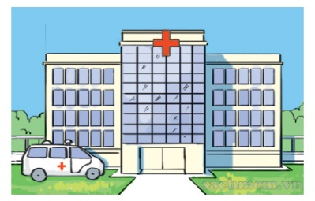  8. tapishol = .........................................
Question 8: Reorder the words to complete sentences. There is ONE example for you. (1pt)
Example: 0. that / Who / is / ? Who is that?
1. do /mother/ what / does/ your ? .......................................................................
2. her/ my/ loves/ teacher/ work/ pupils/ and. ............................................................
3. going/ Christmas carols/ I / sing/ am/ to. ............................................................
4. scary/ tigers/ they/ like/ I/ because/ are/ don/t. .....................................................................................................................................
5. like/ mother/ what/ your/ does/ look.................................................................
6. because/ wants/ wants/ to/ to/ go/ the/ books/ bookshop/ he/ he/ some.
………………………………………………………..................................
7. me/ brother/ is/ older/ my/ than.
…………………………………………..................................................
8. mother/ up/ does/ your/ time/ get/ what ?
……………………………………………………………………………
9. you/ the/ like/ zoo/ go/ this/ to/ would/ to / Saturday?
……………………………………………………………………………
10. beautiful/ zebras/ they/ like/ I/ because/ are.
……………………………………..............................................................
11. some/ she/ she/ supermarket/ food/ the/ go/ to/ to/ wants/ wants/ because.
………………………………………………………..................................
12. father/ does/ your/ time/ get/ what/ up ?
…………………………………………..................................................
13. are/ their/ house/ decorating/ they. ……………………………………………………………………………
14. How/ are/ trousers/ much/ the?
……………………………………………………………………………..
15. number/ your/ is/ phone/ what?
………………………………………………………………………..
Question 9: Write about your favourite food and drink

My name is.........................................
I love................................ It’s ..............................................................food.
I like.................................. It’s .............................................................drink.

Question 10: Write
Dear..........,
My name’s................................. I’m ...........................years old.
There are ................................people in my family.
My father’s..........................................................................................
My mother’s........................................................................................
Best wishes,
....................................

PHÒNG GD & ĐT HẠ LONG
TRƯỜNG TH BÃI CHÁY
HƯỚNG DẪN ÔN TẬP HỌC KỲ II TIẾNG ANH 5
NĂM HỌC 2019 – 2020
A-LÝ THUYẾT
Unit 11:
- Vocabulary: arm, headache, earache, sore eyes, stomachache, toothache, backache, sore throat, temperature, cold, matter, should.
- Sentence patterns: + What’s the matter with you? I have a headache.
I have got a sore throat.
+ You should see the doctor.
You shouldn’t eat ice - cream.
Unit 12:
- Vocabulary: knife, matches, stairs, stove, arm, leg, fall off, fall down, scratch, cut, break, climb, lighter, bite, drown.
- Sentence patterns:
+ Don’t ride too fast. You may fall off your bike. Ok, I won’t.
+ Why shouldn’t they jump into the river? Because they may drown.
Unit 13:- Vocabulary: free time, karate, camping, skating.
- Sentence patterns:
+ What do you do in your free time? I often draw pictures.
+ What does she/he do in his/her free time ? He/ she......
Unit 14:
- Vocabulary: order, far away, watermelon, seed, intelligent, greedy.
- Sentence patterns:
+ What happened in the story? First,/ Then/ Next/ In the end.
+ What do you think of.....? I think.........
Unit 15: Vocabulary: pilot, writer, architect, patient, look after, design.
- Sentence patterns:
+What would you like to be in the future? I’d like to be a/ an .....
+ Why would you like to be..........? Because I’d like to...............
Unit 16:
- Vocabulary: bus stop, post office, theatre, museum, next to, opposite, between, on the corner.
- Sentence patterns: + Excuse me, where’s the .........?It’s ..............
+ How can I get to ..........? You can ................
Unit 17:
- Vocabulary: a bowl, packet, bar, glass, cartoon, bottle of, sausage, egg, biscuit, chocolate.
- Sentence patterns:
+ What would you like to eat/ drink? I’d like ....., please.
+ How many/ much ...... do you eat/ drink every day? I eat/ drink ...........
Unit 18:
- Vocabulary: snowy, wind, foggy, warm, cool, spring, summer, autumn, winter, snow, forecast, season, dry, wet, tomorrow.
- Sentence patterns:
+ What will the weather be like tomorrow? It will be .....and .......
+ What’s ......like in your country? It’s usually ......./ They is/ are.......
Unit 19:
- Vocabulary: museum, pagoda, bridge, temple, attractive, exciting, interesting, expected.
- Sentence patterns:
+ Which place would you like to visit, .....or ......? I’d like to visit .......
+ What do you think of ......? It’s more .....than I expected.
Unit 20: Vocabulary: noisy, noisier, busier, expensive, exciting, peaceful.
- Sentence patterns: + Which one is ...., ...... or .....? I think ......
+ Which one is more ....., .....or ....? I think.......
B-EXERCISES:
I-LISTENING
Part 1: Listen and tick ()
- a. A doctor …. b. A writer …. c. A teacher …
- a. a teacher … b. A farmer … c. An architect …
- a. A pilot … b. A driver … c. A footballer …
Part 2: Listen and number.
- I often go skating in the park.
- You shouldn’t eat sweets.
- I am going to ride my bike with my friends.
- I’d like to be a pilot when I grow up.
Part 3: Listen and write.
Name | Season | Weather
Tony | winter | cold, a lot of (1) ...
Akiko | (2) ... | cold, a lot of (3) ...
Part 4: Listen and circle a,b or c.
- Tom thinks Phu Quoc is more …….. than he expected.
- exciting B. interesting C. beautiful
- Phong thinks Dam Sen Park is more ……… than he expected.
A. interesting B. beautiful C. exciting
3. Tony thinks Nha Trang is more ………. than he expected.
A. attractive B. beautiful C. exciting
Part 5: Listen and number.
A.You can take a bus from here…………
B. The post office is between the supermarket and the cinema……………..
C. I went to the zoo yesterday afternoon……………..
D. It’s often hot in summer. ………………..
Part 6: Listen and complete.
1. The weather in Ha No is (1)________________ and (2)______________
2. Linda would like to eat some (3)____________ and fish and (4) _____________ a glass of milk.
II- READING
Part 1: Read and do the task.
1: Read and complete.
won’t cooking run answered room Peter
One day (0) Peter was bored. He was in his (1)…………....... and his mother was (2)…………....... in the kitchen. She asked loudly “Where are you, Peter? He (3)…………......., “I’m upstairs, Mum.” His mother heard him running down and said “Don’t (4)………….......down the stairs!” Peter replied “OK, I (5)…………....... do it again, Mum.
2.Read the passage again and tick () True or False
 | T | F
Example: 0. His name is Peter
1. Peter was in the kitchen.
2. Peter’s mum is in the garden.
3. Peter was in the upstairs.
4. He was running down the stairs.
5. He said he won’t run down stairs again.

Part 2: Read and do the task.
1.Read and complete.
summerEngland swimmingfishingwarmseasons
Linda is from (0)England. There are four (1)...........................in her country. In(2)................., it is hot. She often goes (3)........................ In autumn, it is cool and wet. Her father and she sometimes go (4)...................... It is very cold in winter. They usually go skiing in the mountains. In spring, it is (5).....................and beautiful. They often go camping in the national park.
2. Read the passage again and tick () True or False
 | T | F
Example: 0. Linda is from England
1. There are five seasons in her country.
2. Her father and she sometimes go fishing
3. They usually go skiing in the mountains in winter
4. In spring, it is cool and beautiful
5.They often go camping in the national park.
3. Read the passage again and answer the questions:
1.How many seasons are there in Linda’s country?
=>...........................................................................................................................................
2. What does she often do in the summer?=>...................................................................
3. What does she often do in thautumn?=>.......................................................................
4. What is the weather like in winter?=>..........................................................................
5. What do they often do in the spring?=>........................................................................
Part 3: Read and do the task.
1.Read and complete.
pagodavisiteda lot ofbeautifulcentrefriends
My name’s Nam. Yesterday, I (0) visitedTran Quoc (1) ____________. It is on an island in the middle of West Lake and not far from the (2) __________ of Ha Noi. I went there by bike. Tran Quoc pagoda is very quiet. It is more (3) ____________ than I expected. There are (4) _________statues and trees in the yard. I met some (5) ____________ there. My friends and I learnt more about the history of Ha Noi after the visit.
2. Read the passage again and tick () True or False
 | T | F
Example: 0. His name is Nam
1. Nam visited Tran Quoc pagoda yesterday.
2. The pagoda is far from Ha Noi.
3. Tran Quoc pagoda is noisy and not nice .
4. There aren’t any trees in the yard.
5. Nam learnt more about the history of Ha Noi.

3. Read the passage again and answer the questions:
1. When did Nam visit Tran Quoc Pagoda?=>..................................................................
2. Where isTran QuocPagoda ?=>...................................................................................
3. How did he get there ?=>...............................................................................................
4. What does Nam think of Tran QuocPagoda ?
=>...........................................................................................................................................
5. What did Nam and his friends learn about ?
=>...........................................................................................................................................
Part 4: Read and do the task.
1.Read and complete.
mountain beautiful king history by is
My name is Land. Yesterday morning, I visited the Temple of (1)…………….Hung in Phi Though Province. I went there (2)……………..bus with my classmates. The temple is on Nigh Line(3)……………… It’s more (4)………………………..than I expected. My classmates liked the temple a lot. They said that the visit helped them to learn more about the (5)………… of Viet Nam and the people.
2. Read the passage again and tick () True or False
 | T | F
Example: 0. Her name is Land
1. Last week Land visited the Temple of King Hung.
2. She went there with her classmates
3. It’s more exciting than she expected.
4. Her classmates did not like the temple.
5.They learn more about the history of Viet Nam and the people after their visit.
3. Read the passage again and answer the questions:
1. When didweek Land visit the Temple of King Hung ?
=>...........................................................................................................................................
2. How did they get there ?=>...............................................................................................
3. Where is the Temple of King Hung ?=>....................................................................................
4. What does Land think of the Temple of King Hung ?
=>...........................................................................................................................................
5. What did Lan and her classmates learn about ?
=>...........................................................................................................................................
III-WRITING: Part 1:Order the letters to make a complete word
1. ehcahtoot = | 6. gesausas =
2. tolpi = | 7.cymarpha =
3. telacocoh = | 8. terwir =
4. ynnus = | 9. ysnow =
5. dyclou = | 10.ytorms =
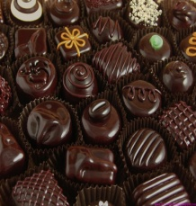

(1)…………… (2)…………… (3)…………… (4)…………… (5)……………

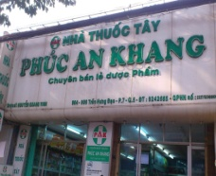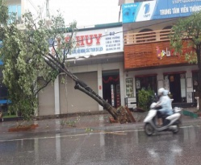

(6)…………… (7)…………… (8)…………… (9)…………… (10)……………
Part 2:Put the words in order to make the sentences
Example:0. want/ what/ do/ animal/ see/ to/ you/?→What animal do you want to see?
Yes
1. would / like / what / you / be / to/ in/ future/the ?
=> ....................................................................................................................................
2. will/ what / like/ weather/ be/ the/ tomorrow?
=>....................................................................................................................................
3. often/ cartoons/ watches/ TV/ he / on
=>....................................................................................................................................
4. next to/ the / post office / the/ is/ cinema/ .
=>....................................................................................................................................
5. Where / you/ go /last / did / weekend?=>....................................................................................................................................
6. I / to / Phu Quoc/ Island/ went.
=>....................................................................................................................................
7. I / like / sandwich / a / an /and / apple/ would /, please. =>................................................................................................................................
8. How/ eggs / you / eat/ do / many /every day?
=>...............................................................................................................................
9. How / water/much / you / drink / do /every day?
=> ..............................................................................................................................
10. My mother/ a / of / likes/ glass/ orange juice / every day.
=>..............................................................................................................................
11. spring / like/ what/ country / is /your / in ?
=>..............................................................................................................................
12.usually / it/ warm/ is/ and/ there ‘re / flowers/ a lot of.
=>..............................................................................................................................
13.would/ place/ you/ which/ to/ visit/like ?
=>..............................................................................................................................
14.would / I / Ha Long Bay/ to/ visit/like.
=>....................................................................................................................................
15. like/ I/ autumn/ the/ because/ weather/ cool/ is/.
=>...........................................................................................................................................
16.expected/ beautiful/ than/ it’s/ more/ I.
=>...........................................................................................................................................
entrance/ stop/ the/ is/ of/ the/ at/ bus/ zoo/ the.
=>...........................................................................................................................................
18. like/ would/future/the/you/to/what/be/in? =>...........................................................................................................................................
19. sister/ like/ my/ would/ a teacher/ to/ be/ the/ in/ future.
=>...........................................................................................................................................
20. do/ eat/ you/ sausages/ every/ day/ many/ how?
=>...........................................................................................................................................
Part 3: Writing.
1. What would you like to be in the future?
=>....................................................................................................................................
2. What do you do in your free time? =>....................................................................................................................................
3. What does your mother do in her free time?
=>...........................................................................................................................................
4. What does your brother do in his free time? =>....................................................................................................................................
5. How many apples do you eat every day? =>....................................................................................................................................
6. How much rice do you eat every day?=>..............................................................................................................................
7. What’s your favorite season?
=>....................................................................................................................................
8. What’s the weather like in your favorite season? =>..............................................................................................................................
9. What’s the weather like today? =>..............................................................................................................................
10. What will the weather be like tomorrow?
=>..............................................................................................................................

